**HOW TO GENERATE SSH KEY AND FIRST TIME CONNECITION OF GITHUB TO LOCAL SYSTEM.**

REFER this link: <https://www.youtube.com/watch?app=desktop&v=N7rnWktLiuU&list=LL&index=20>

**HOW TO CREATE REPOSITORY IN GITHUB SUCH THAT IT GETS CONNECTED(upload/download) FROM THE LOCAL SYSTEM:**

1] create a repository at Git Hub.

2] Copy the HTTPS link, given there.

Ex] <https://github.com/Amit-Modh/CPP-code_practice.git>

3] open the terminal in Linux.

4] write command:

git clone https://github.com/Amit-Modh/CPP-code_practice.git

5] press enter then.

(this will create an folder at our local machine)

Ex] See inside HOME>> CPP-code_practice folder.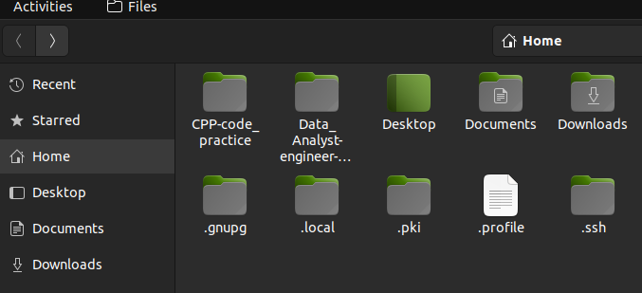

Inside this CPP-code_practice folder, we can see the git folder. This shows that our repository and system got connected. **See the below image(last folder shows git folder**, and if it is invisible than use “CTRL+H” command, so that it will show all the hidden files.)

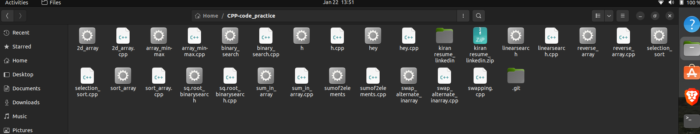

6] **how to upload our file into github???**

7] Open terminal, and get into CPP-code_practice folder. (USE command “cd CPP-code_practice”)

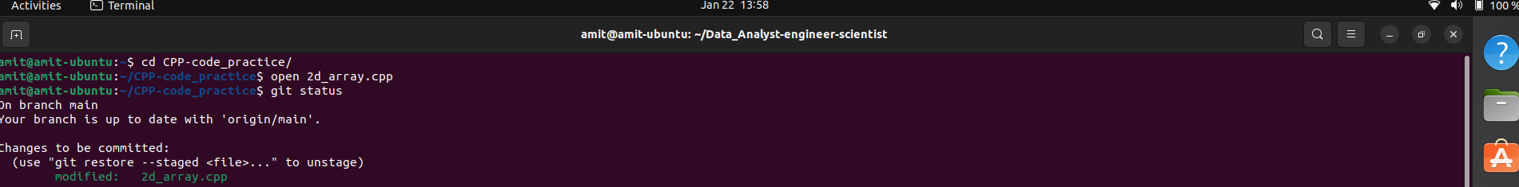

8] use the following commands:

a]git status (output: empty repository)

b]git add . (dot represents all files to get uploaded if we need to upload single file then use, git add <filename.extension> )

c]git commit -m “first commit”

d]git push

e]git status (output: shows files inside the repo)

***Ex] here used data_analyst folder having a single file named as dataAnalyst_codebasics_roadmap.pdf***

See steps [a] below

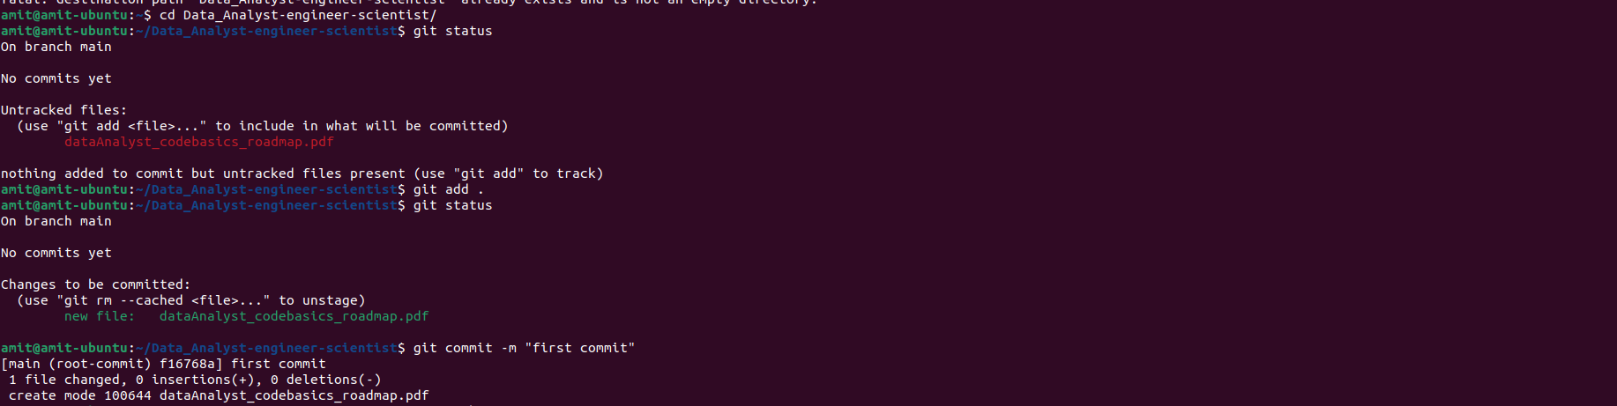

See steps b] to e] below

